**Software Requirements**

**Specification**

**for**

**Campus Management Application**

**at**

**World Skill Center (WSC)**

**Business Feature - Infrastructure Module**

**Sustainable Outreach And Universal Leadership (SOUL) Limited**

**Version no#**

**Table Of Content**

1. Introduction 2

2. Land 3

3. Buildings 5

4. Building Room 6

5. Application for Residence 9

6. Residence Allotment 10

7. Employee 12

8. Application for Residence De-Allottment 13

9. Residence De-Allottment 14

10. Residence Change Request (Workflow) 15

# Introduction

* 1. **Document Overview**

This document presents the software requirements specifications of Campus Management Application Infrastructure module.

It describes the following :

* Scope
* Functionality of the modules / sub modules
* User Interface
* Field Types
* Intended Users
  1. **Scope**

The scope of this document are the features of the Infrastructure Module

1. Land, Buildings
2. Building Room
3. Application for Residence
4. Residence Allotment
5. Application for Residence De Allotment
6. Residence De Allotmen
7. Residence Change request
   1. **Intended Users**

The system shall be available to and accessible by the Administrator and the applicant(employee).

1. **Land**

This is a master screen which holds data regarding the land.Land here is in reference to the plot of land on which the building is built.

Operations on this screen can be performed by the administrator only.

In this screen, administrator shall enter all the details regarding the land for the building and click Save button

On Save, the land shall be created.

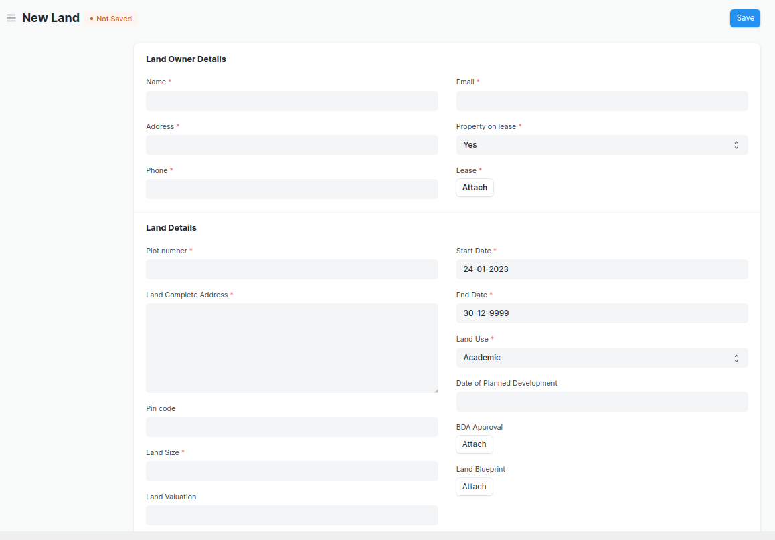

**The “Land” screen shall consist of the following fields:**

|  |  |  |  |
| --- | --- | --- | --- |
| **Label (Fields)** | **Type (Fields)** | **Options (Fields)** | **Mandatory** |
| Land Owner Details | Section Break |  |  |
| Name | Data |  | Y |
| Address | Data |  | Y |
| Phone | Data |  | Y |
| Email | Data |  | Y |
| Property on lease | Select | Yes  No | Y |
| Lease | Attach |  |  |
| Land Details | Section Break |  |  |
| Plot number | Data |  | Y |
| Land Complete Address | Small Text |  | Y |
| Pin code | Data |  |  |
| Land Size | Data |  | Y |
| Land Valuation | Currency |  |  |
| Start Date | Date |  | Y |
| End Date | Date |  | Y |
| Land Use | Select | Academic  Residential  Both | Y |
| Date of Planned Development | Date |  |  |
| BDA Approval | Attach |  |  |
| Land Blueprint | Attach |  |  |

1. **Buildings**

This is a master screen for Buildings. All the building information shall be stored here. The buildings can be residential, academic or both. The actions on this screen can be performed by the administrator only.

Administrator shall enter all the details regarding the building and click Save button

On Save, the building shall be created.

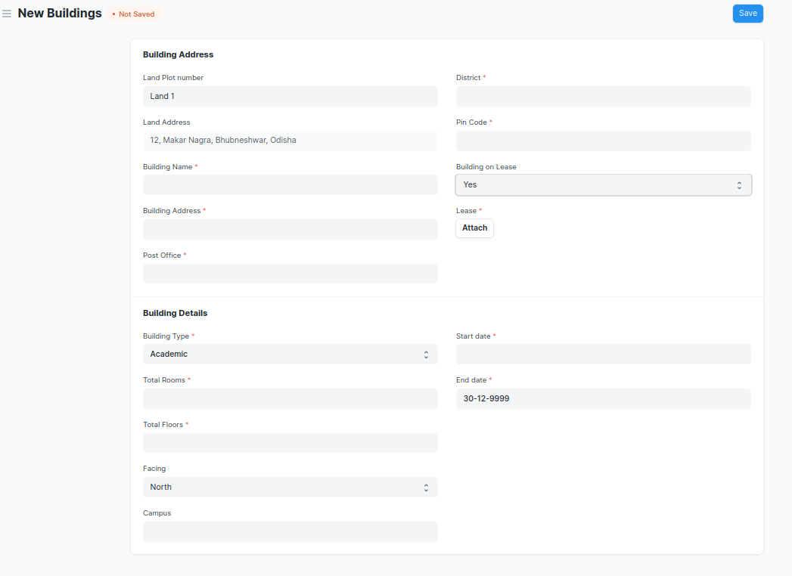

**“Buildings” screen shall consist of the following fields:**

|  |  |  |  |
| --- | --- | --- | --- |
| **Label (Fields)** | **Type (Fields)** | **Options (Fields)** | **Mandatory** |
| Building Address | Section Break |  |  |
| Land Plot number | Link | Land |  |
| Land Address | Data |  |  |
| Building Name | Data |  | Y |
| Building Address | Data |  | Y |
| Post Office | Data |  | Y |
| District | Link | Districts | Y |
| State | Data |  | Y |
| Pin Code | Data |  | Y |
| Building on Lease | Select | Yes  No | Y |
| Lease | Attach |  | Y |
| Building Details | Section Break |  |  |
| Building Type | Data | Academic  Non-Academic | Y |
| Total Rooms | Data |  |  |
| Total Floors | Date |  | Y |
| Facing | Date | North  South  East  West | Y |
| Campus | Data |  | Y |
| Start date | Date |  |  |
| End date | Date |  |  |

1. ****Building Room****

**This is a master screen, in which we shall be storing the building’s room details and classifying the rooms. This screen also help us assign a number to the residence ( For e.g, Residence number).**

**The operations on this screen can be performed by the Administrator only.**

**In this screen, the user shall select the type of room and, based on selection, the type of residence shall be fetched. Further on selection of type of residence, the residence type name(e.g. 2BHK) drop down shall be fetched.**

**After selection of Residence Type name:**

* **All the related information about the residence shall be fetched**
* **The user should set the Start and End dates for the residence.**
* **Then the user shall click the save button**
* **On the click of the save button, the residence is created.**

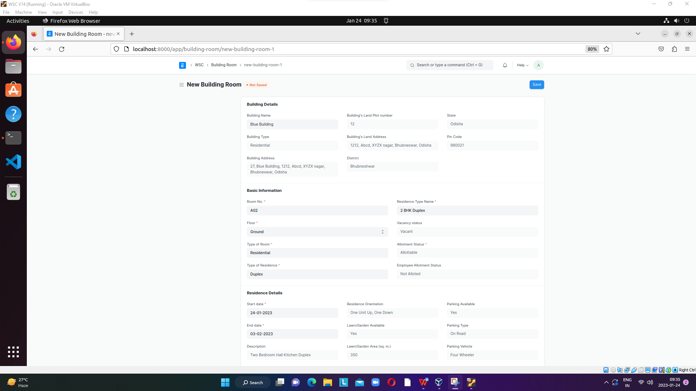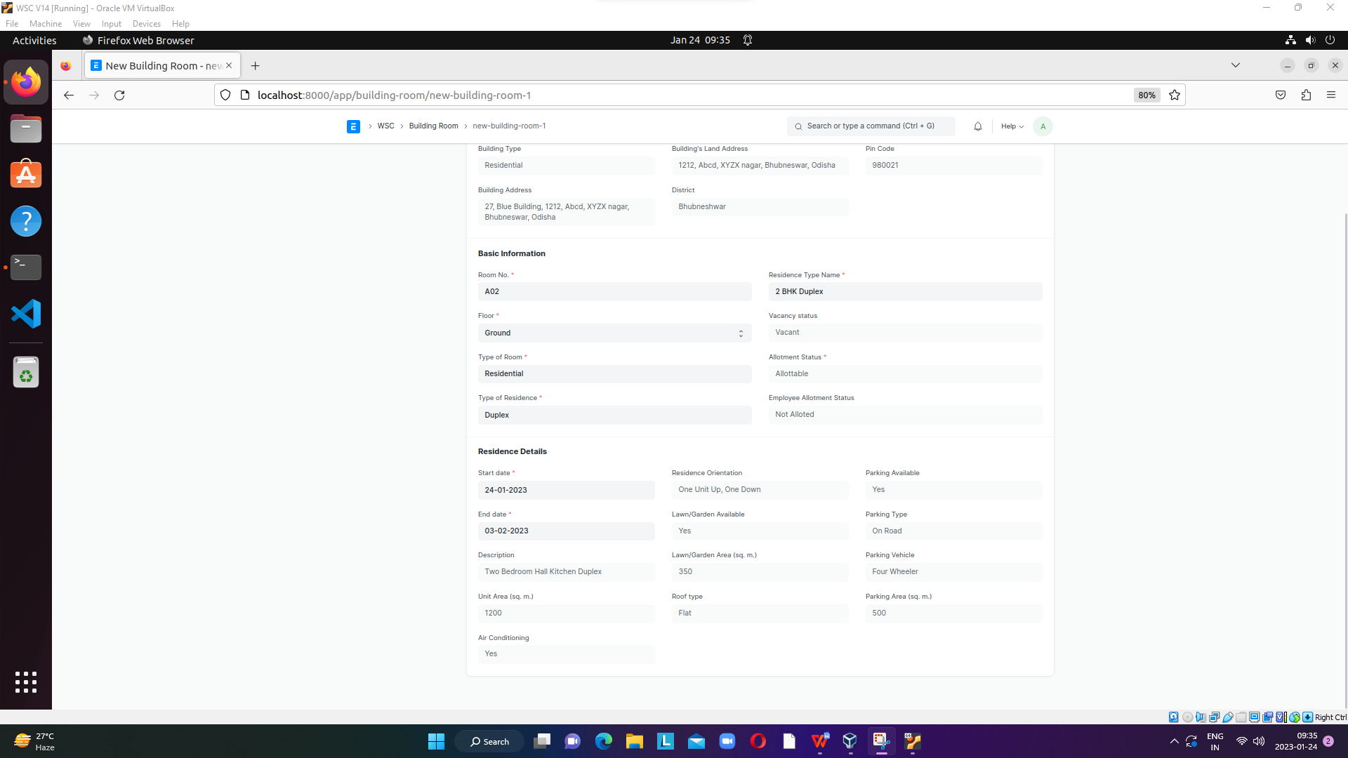

**“Building Room” screen shall consist of the following fields:**

|  |  |  |  |
| --- | --- | --- | --- |
| **Label (Fields)** | **Type (Fields)** | **Options (Fields)** | **Mandatory** |
| Building Details | Section Break |  |  |
| Building Name | Link | Buildings |  |
| Building Type | Data |  |  |
| Building Address | Data |  | Y |
| Building's Land Plot number | Data |  | Y |
| Building's Land Address | Data |  | Y |
| District | Data |  | Y |
| State | Data |  | Y |
| Pin Code | Data |  | Y |
| Basic Information | Section Break |  | Y |
| Room No. | Data |  | Y |
| Floor | Data | Ground  1 ….. |  |
| Type of Room | Link | Building type Room | Y |
| Type of Residence | Link | Type of Residence | Y |
| Residence Type Name | Link | Residence Type | Y |
| Vacancy status | Select | Vacant  Not Vacant |  |
| Allotment Status | Data |  |  |
| Employee Allotment Status | Data |  |  |
| Residence Details | Section Break |  |  |
| Start date | Date |  |  |
| End date | Date |  |  |
| Description | Data |  |  |
| Unit Area (sq. m.) | Data |  |  |
| Air Conditioning | Data |  |  |
| Residence Orientation | Data |  |  |
| Lawn/Garden Available | Data |  |  |
| Lawn/Garden Area (sq. m.) | Data |  |  |
| Roof type | Data |  |  |
| Parking Available | Data |  |  |
| Parking Type | Data |  |  |
| Parking Vehicle | Data |  |  |
| Parking Area (sq. m.) | Data |  |  |

* 1. ****Building type Room****

**This screen helps define the type of the room, for example if it is a classroom or residential or conference hall. The operations on this screen can be performed by the Administrator only.**

**This screen shall have only these two fields:**

|  |  |  |  |
| --- | --- | --- | --- |
| **Label (Fields)** | **Type (Fields)** | **Options (Fields)** | **Mandatory** |
| Type of Room | Data |  | Y |
| Allotment Status | Select | Allottable  Non Allottable | Y |

* 1. ****Type of Residence****

**This screen helps in the classification of residence, whether it shall be a quarter or a duplex or even a villa. The operations on this screen can be performed by the Administrator only.**

**This screen shall have only one field which is as follows:**

|  |  |  |  |
| --- | --- | --- | --- |
| **Label (Fields)** | **Type (Fields)** | **Options (Fields)** | **Mandatory** |
| Type of Residence | Data |  | Y |

* 1. ****Residence Type****

**This screen helps in further classification of residences in a building room based on types of residence. Example: 2BHK Quarter or 4BHK Villa and so on. The operations on this screen can be performed by the Administrator only.**

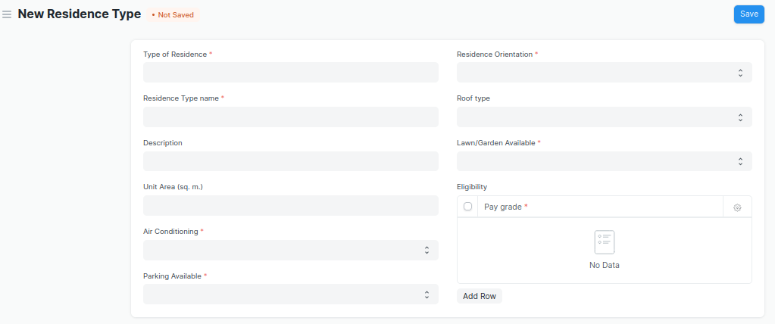

**The “Residence Type” screen shall consist of the following fields:**

|  |  |  |  |
| --- | --- | --- | --- |
| **Label (Fields)** | **Type (Fields)** | **Options (Fields)** | **Mandatory** |
| Type of Residence | Link | Type of Residence | Y |
| Residence Type name | Data |  | Y |
| Description | Data |  |  |
| Unit Area (sq. m.) | Data |  |  |
| Air Conditioning | Select | Yes  No | Y |
| Parking Available | Select | Yes  No | Y |
| Parking Type | Select | On Road  Ramp Parking  Lot Parking  Garage  Shed |  |
| Parking Vehicle | Select | Two Wheeler  Four Wheeler |  |
| Parking Area (sq. m.) | Data |  |  |
| Residence Orientation | Select | Multi storey  One Unit Up, One Down  Side-By-Side | Y |
| Roof type | Select | Flat  Gable  Hip  Gambrel  Mansard |  |
| Lawn/Garden Available | Select | Yes  No | Y |
| Lawn/Garden Area (sq. m.) | Data |  |  |
| Eligibility | Table | Residence Eligibility |  |

* 1. ****Residence Eligibility****

**Residence Eligibility is a child screen which includes only one field, namely Pay grade. This is to define which residence type is eligible to be allotted to which pay grade.**

**This child screen shall have only this one fields:**

|  |  |  |  |
| --- | --- | --- | --- |
| **Label (Fields)** | **Type (Fields)** | **Options (Fields)** | **Mandatory** |
| Pay grade | Data |  | Y |

1. ****Application for Residence****

**In this screen, the applicant(employee) shall apply for a residence and request the type of residence he/she wants. The operations on this screen can be performed by the applicant only.**

* **After filling up the form, the user shall click on the save button.**
* **Post save user shall click on the “submit” button and application status shall appear to be “Applied”**

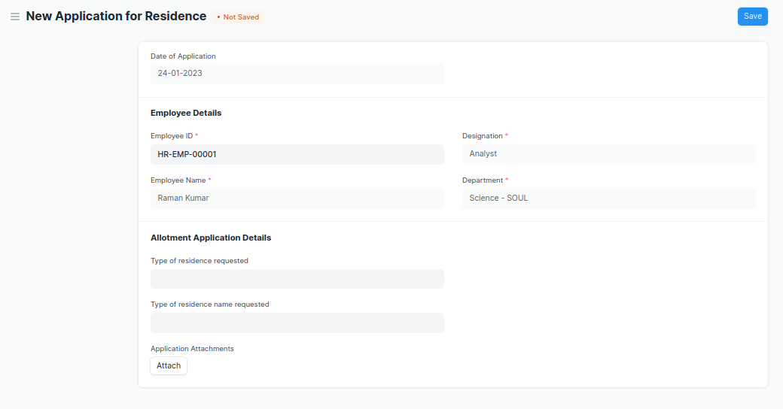

**The “Application for Residence” screen shall consist of the following fields:**

|  |  |  |  |
| --- | --- | --- | --- |
| **Label (Fields)** | **Type (Fields)** | **Options (Fields)** | **Mandatory** |
| Date of Application | Link |  |  |
| Application Number | Data |  |  |
| Employee Details | Data |  |  |
| Employee ID | Data | Employee | Y |
| Employee Name | Data |  | Y |
| Designation | Data |  | Y |
| Department | Data |  | Y |
| Allotment Application Details | Section Break |  |  |
| Type of residence requested | Link | Type of Residence |  |
| Type of residence name requested | Link | Residence Type |  |
| Application Attachments | Attach |  |  |
| Application Status | Data |  |  |
| Current Application Status | Data |  |  |

1. ****Residence Allotment****

**This screen shall assist the Administrator to allot the vacant and not allotted residences to the applicants. The operations on this screen can be performed by the Administrator only.**

****Pre-Requites:** Application for residence should be in the “Applied” state.**

* **The user shall select the application number. All the relevant details shall be fetched.**
* **The user shall select “Approved” status. The approval status field shall have the following values :**

1. **Approved**
2. **Pending**
3. **Rejected**

* **On selection of Approved, user shall fill the fields such as Start date, End date, Building,** Residence Type, Residence Type Name, Residence number. Then the allotted residence details shall be auto fetched.
* The user shall click the Save and Submit button.
* After successful submission, the current application status of “**Application for Residence“** shall change to “Allotted”.
* On selection of either pending or rejected, the application status shall change in the “Application for Residence” screen .

**Now the user needs to give the approval status. On the basis of the selection, the user can further proceed to allotment of residence.**

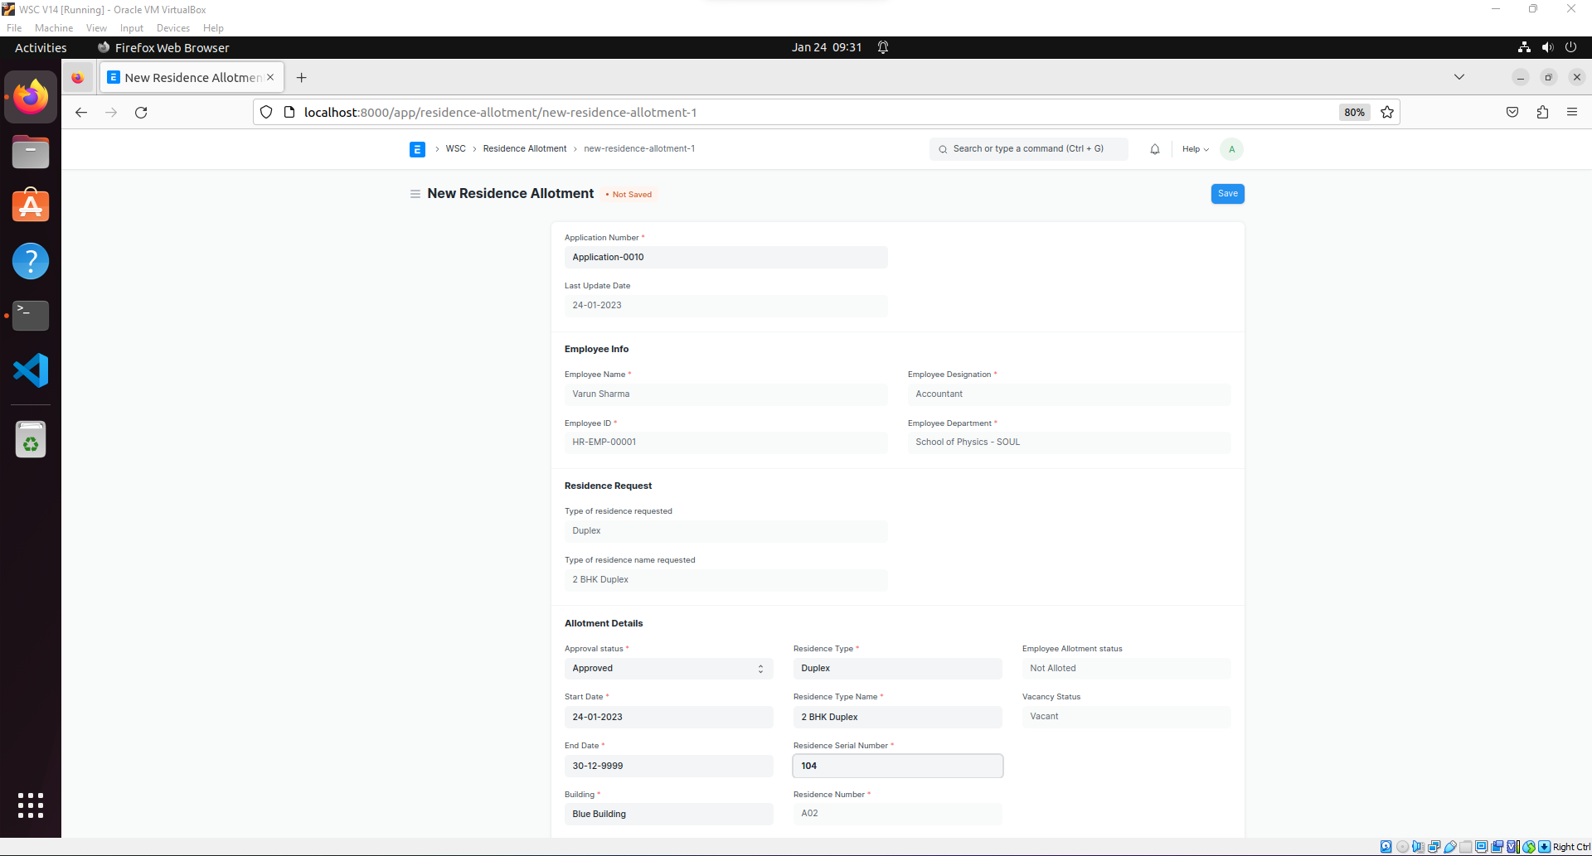

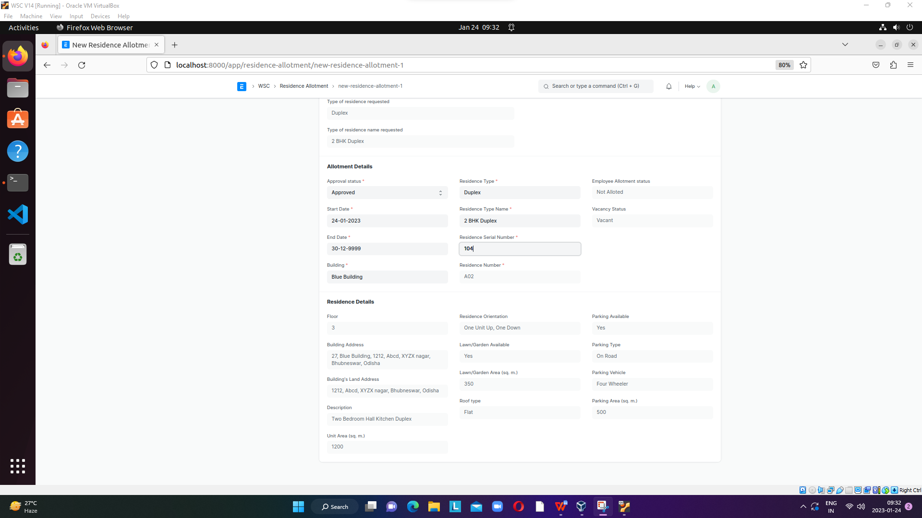

**The “Residence Allotment” screen shall consist of the following fields:**

|  |  |  |  |
| --- | --- | --- | --- |
| **Label (Fields)** | **Type (Fields)** | **Options (Fields)** | **Mandatory** |
| Residence Allotment Number | Link |  |  |
| Application Number | Data |  |  |
| Last Update Date | Data |  |  |
| Employee Info | Data | Employee | Y |
| Employee Name | Data |  | Y |
| Employee ID | Data |  | Y |
| Employee Designation | Data |  | Y |
| Employee Department | Data |  | Y |
| Residence Request | Section Break |  |  |
| Type of residence requested | Data |  |  |
| Type of residence name requested | Data |  |  |
| Allotment Details | Section Break |  |  |
| Approval status | Select | Approved  Pending for Approval  Rejected | Y |
| Start Date | Date |  |  |
| End Date | Date |  |  |
| Building | Link | Buildings |  |
| Residence Type | Link | Type of Residence |  |
| Residence Type Name | Link | Residence Type |  |
| Residence Serial Number | Link | Building Room |  |
| Residence Number | Data |  |  |
| Employee Allotment status | Data |  |  |
| Vacancy Status | Data |  |  |
| Current Employee Allotment status | Data |  |  |
| Current Vacancy Status | Data |  |  |
| Residence Details | Section Break |  |  |
| Floor | Data |  |  |
| Building Address | Data |  |  |
| Building's Land Address | Data |  |  |
| Description | Data |  |  |
| Unit Area (sq. m.) | Data |  |  |
| Residence Orientation | Data |  |  |
| Lawn/Garden Available | Data |  |  |
| Lawn/Garden Area (sq. m.) | Data |  |  |
| Roof type | Data |  |  |
| Parking Available | Data |  |  |
| Parking Type | Data |  |  |
| Parking Vehicle | Data |  |  |
| Parking Area (sq. m.) | Data |  |  |

1. ****Employee****

## 7.1 Residence Allotted (Child table)

**This child table shall reflect the residence allotment details on the employee screen.**

**On approval of residence allotment on the “Residence Allotment” screen, this child table shall be fetched on the Accommodation tab of the Employee screen.**

**“Residence Allotted” child screen shall consist of the following fields:**

|  |  |  |  |
| --- | --- | --- | --- |
| **Label (Fields)** | **Type (Fields)** | **Options (Fields)** | **Mandatory** |
| Residence Allotment Number | Data |  |  |
| Application Number | Data |  |  |
| Residence Type | Data |  |  |
| Residence Type Name | Data |  |  |
| Residence Number | Data |  |  |
| Floor | Data |  |  |
| Building Address | Data |  |  |
| Unit Area (sq. m.) | Data |  |  |
| Parking Available | Data |  |  |
| Parking Type | Data |  |  |
| Parking Area (sq. m.) | Data |  |  |
| Parking Vehicle | Data |  |  |
| Current Employee Allotment status | Data |  |  |

1. ****Application for Residence De-Allottment****

**By filling out this form the applicant(employee) can apply for De-Allotment of the currently allotted residence. The operations on this screen can be performed by the applicant only.**

* **The user shall select the residence allotment number, after which all the relevant details shall be fetched.**
* **The user shall give a reason for de-allotment application.**
* **After clicking on the save and submit button, the “Current Application Status” shall change to “Applied”.**

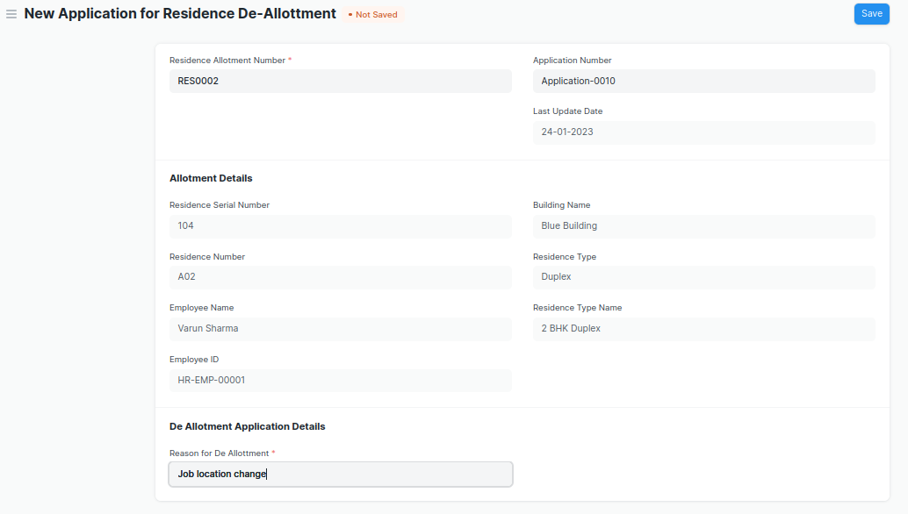

**The “Application for Residence De-Allotment” screen shall consist of the following fields:**

|  |  |  |  |
| --- | --- | --- | --- |
| **Label (Fields)** | **Type (Fields)** | **Options (Fields)** | **Mandatory** |
| Residence De Allotment Number | Data |  |  |
| Residence Allotment Number | Link | Residence Allotment | Y |
| Application Number | Data |  |  |
| Last Update Date | Date | Employee |  |
| Allotment Details | Section Break |  |  |
| Residence Serial Number | Data |  |  |
| Residence Number | Data |  |  |
| Employee Name | Data |  |  |
| Employee ID | Data |  |  |
| Building Name | Data |  |  |
| Residence Type | Data |  |  |
| Residence Type Name | Data |  |  |
| De Allotment Application Details | Section Break |  |  |
| Reason for De Allotment | Data |  | Y |
| Application Status | Data |  |  |
| Current Application Status | Data |  |  |

1. ****Residence De-Allottment****

**This screen shall assist the administrator to De-allot the allotted residences to the employee and turn the status of residences to Vacant and Not Allotted. The operations on this screen can be performed by the Administrator only.**

****Pre-Requites:** Application for residence De-Allotment should be in “Applied” state.**

* **The user shall select the “**Residence De Allotment Number”, after which all the relevant details of the application shall be fetched.
* The user shall click on save and submit to confirm de-allotment.
* After successful submission the application status on “**Application for Residence De-Allottment screen” shall change to “De-alloted”.**

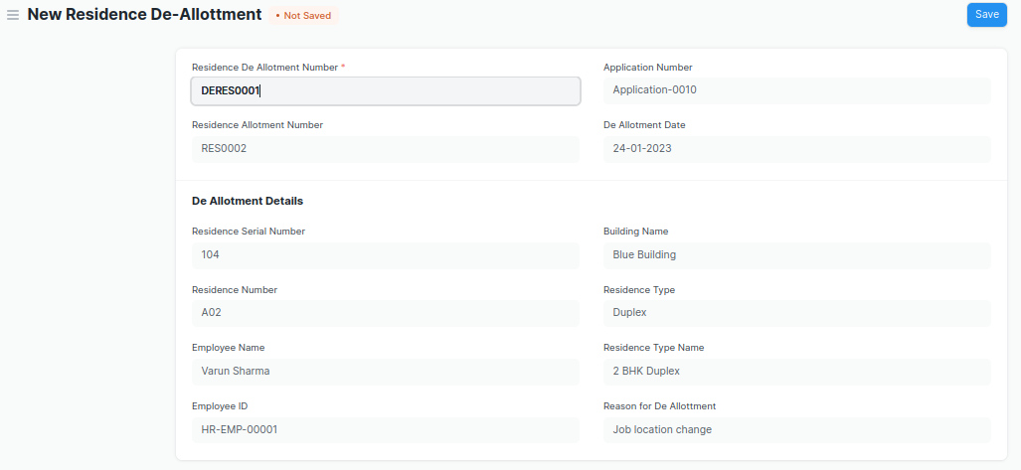

**“Residence De-Allottment” screen shall consist of following fields:**

|  |  |  |  |
| --- | --- | --- | --- |
| **Label (Fields)** | **Type (Fields)** | **Options (Fields)** | **Mandatory** |
| Residence De Allotment Number | Link | Application for Residence De-Allottment | Y |
| Residence Allotment Number | Data |  |  |
| Application Number | Data |  |  |
| De Allotment Date | Date |  |  |
| De Allotment Details | Section Break |  |  |
| Residence Serial Number | Data |  |  |
| Residence Number | Data |  |  |
| Employee Name | Data |  |  |
| Employee ID | Data |  |  |
| Building Name | Data |  |  |
| Residence Type | Data |  |  |
| Residence Type Name | Data |  |  |
| Reason for De Allotment | Data |  |  |

1. ****Residence Change Request (Workflow)****

**With the help of this workflow, the applicant as well as the administration shall be able to get the residence change process done. The operations on this screen can be performed by the Administrator and the Applicant both.**

**The following are the actions which can be performed:**

****Actions by Applicant:****

1. **The applicant shall fill out the form and apply with the requested residence type and residence name**
2. **After the change request is saved and the “send for approval” button is clicked, the screen shall be accessible to the administrator.**

****Actions by Administrator:****

**Two actions can be performed by the administrator:**

1. **The administrator shall fill in the fields for “**Residence Type”, “Residence Type Name” and “Residence serial Number” and click the “approved” button. On approval, allotment and vacancy status shall be changed to vacant and not allotted for the previously allotted residence and not vacant and allotted for the newly allotted residence.
2. **“Pending for approval” or “Rejected” button which shall reflect the appropriate “Application Status” on the “Residence Change Request” screen for the applicant.**